**Report of SSA Coding Assignment**

-Debanshu Biswas (M20MA053)

**Question 1**

I have written the code in MATLAB to execute the given problems. I first loaded given human perceptual data to a variable data_all. This variable contains 2475 examples. To divide the data in 50 different sets I sliced the variable data_all as data=data1(1:2450 , 2:3). So, data variable has 2075 rows and 2 columns.

Then as required I separated two columns of data as X_all and U_all. Then, splitting X_all, U_all into equal 50 sets I set X and U as random variables and X{n}, U{n} are random variables for 1<= n <= 50. So, we get 50 distinct realizations of X and U. There each X{n} and U{n} contains 49 elements.

**Question 2**

For question 2, first we need to enter value of n1 and n2 and these values must be between 1 and 50.

Here, for report we fix n1=5 and n2=27.

1. For finding probablity density function and culmulative density function we used Kernel Distribution Estimation in MATLAB. There they use a estimate to estimate random variable. The estimate is

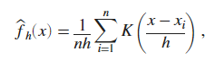

We fitted our data to smoothing variables

pd_xn1 = fitdist(X{n1},'Kernel');

pd_xn2 = fitdist(X{n2},'Kernel');

I plotted probability density function and cumulative density function of X[n1] and X[n2]. The combined plotted graph is below,

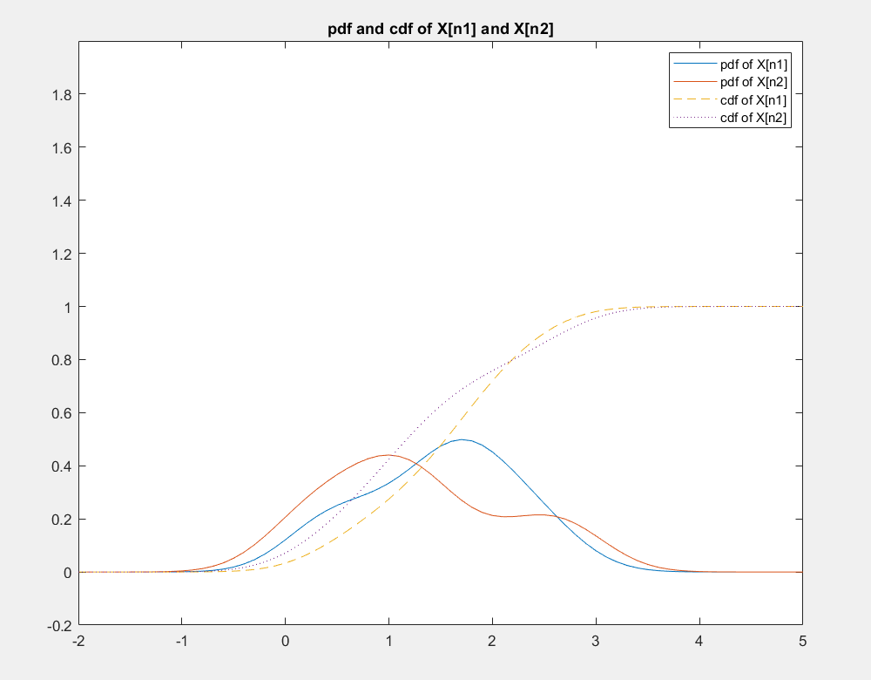

1. Then, I computed mean and variance for X[n1] and X[n2]. I got,

Mean of X[n1] is 1.491

Mean of X[n2] is 1.287

Variance of X[n1] is 0.500

Variance of X[n2] is 0.732

c. We then computed covariance matrix of X[n1] and X[n2)]. Which is given below,

0.5000 -0.0948

-0.0948 0.7317

Then, I computed joint probability density function of X[n1] and X[n2]. For this I used one function kde2d and the full coding of this function is given at the end of the programming file. And we used the code

joint=[X{n1} X{n2}];

[bandwidth,density,X,Y]=kde2d(joint);

Above density is our desired joint density function.

Then I plotted the graph for that in 3 dimensions. I request you to please see the 3d graph generated by MATLAB for best experience. But one image of the graph is given below.

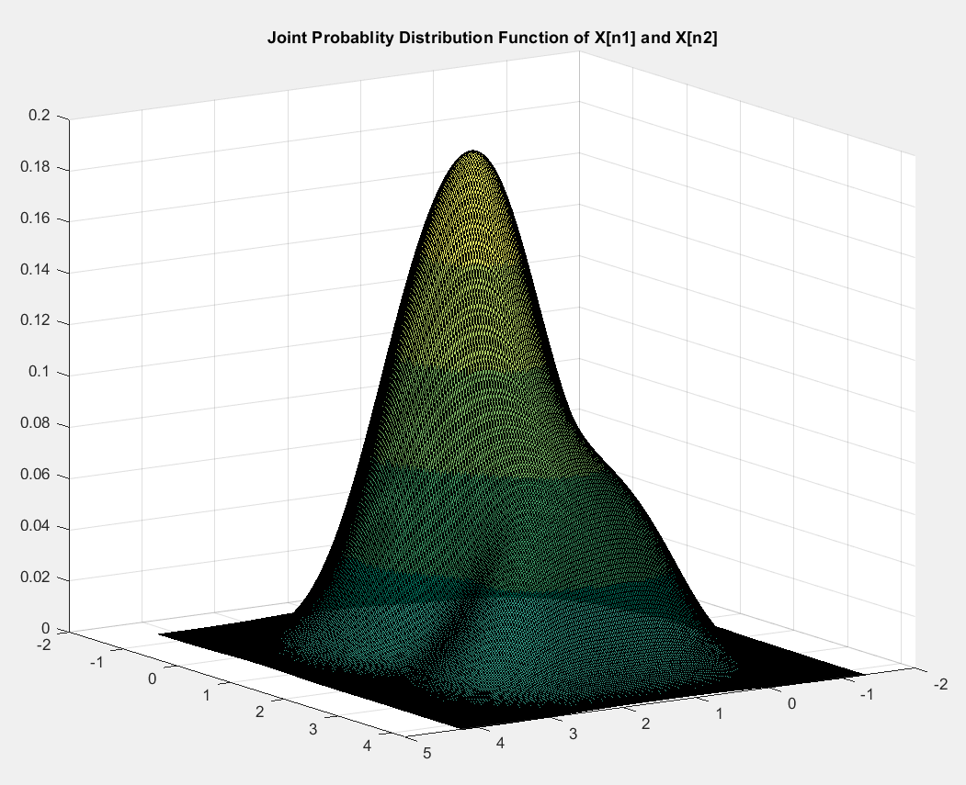

1. To check if the two random variables X[n1] and X[n2] are correlated or dependent I wrote a full program to check. We got result as,

X[5] and X[27] are correlated.

And, hence X[5] and X[27] are dependent random variables.

And, as the cross diagonal entry of covariance matrix of X[n1] and X[n2)] is non zero this also directly imply the same as above.

1. To check if the two random variables X[n1] and X[n2] are stationary and dependent I wrote a full program to check. We got result as,

As mean and variance of the random variables X[n] in random process X is varying for different values of n then, the random process X is not a stationary random process

As mean of the random variables X[n] in random process X is not constant for different values of n then, the random process X is not a Wide Sense Stationary random process

**Question 3**

Here also we work with same values of n1 and n2. So, n1=5 and n2=27.

1. For finding probability mass function of U[n1] and U[n2] I used histogram to plot it.

The PROBABILITY MASS FUNCTION is the number of times each value in random variable is obtained, divided by the total number of experiments. We will use here histogram function with 'Normalization' and 'pdf' to get the probability mass function.

Plotted probability mass function of U[n1] and U[n2] is below,

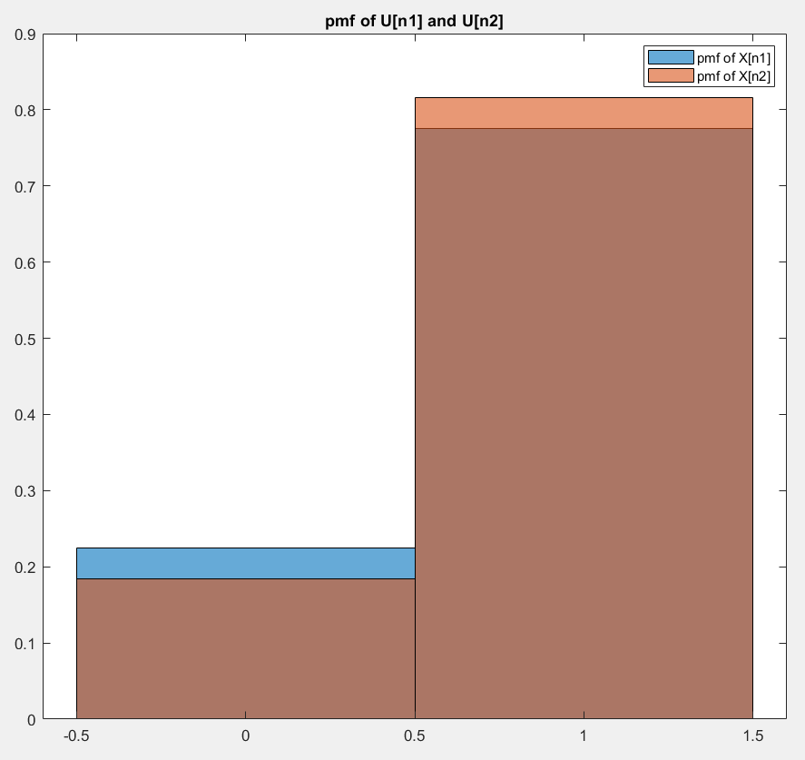

Separately, I have calculated

probability mass function of U[n1] is

U[1]= 0.7755 , U[0]= 0.2245

probability mass function of U[n2] is

U[1]= 0.8163 , U[0]= 0.1837

1. Then, I computed mean and variance for U[n1] and U[n2]. I got,

Mean of U[n1] is 0.776

Mean of U[n2] is 0.816

Variance of U[n1] is 0.178

Variance of U[n2] is 0.153

c. We then computed covariance matrix of U[n1] and U[n2]. Which is given below,

0.5000 -0.0948

-0.0948 0.7317

Then, I wrote a proper code for finding joint probability mass function of U[n1] and U[n2)]. We got probability mass function as,

Joint probability mass function of U[n1] and U[n2] is

0 1

0 0.0408 0.1837

1 0.1429 0.6327

I plotted the joint probability mass function of U[n1] and U[n2] as below,

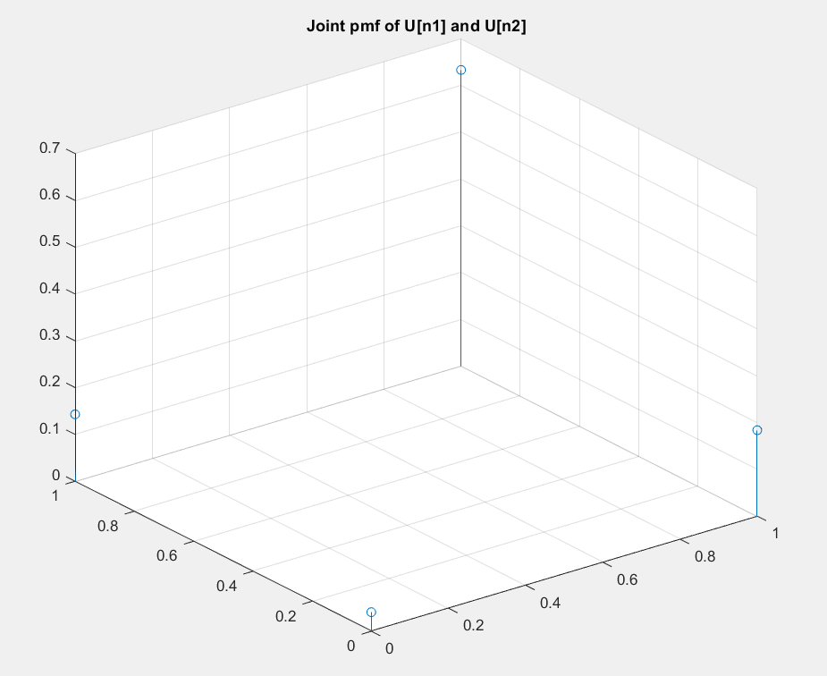

And, we got covariance matrix of U[n1] and U[n2] is

0.1777 -0.0004

-0.0004 0.1531

d. To check if the two random variables U[n1] and U[n2] are correlated or dependent I wrote a full program to check. We got result as,

U[5] and U[27] are correlated.

And, hence U[5] and U[27] are dependent random variables.

And, as the cross diagonal entry of covariance matrix of U[n1] and U[n2)] is non zero this also directly imply the same as above.

And, for case n2 – n1 = 1, we got result,

We observe that mean of U[6] is 0.9388 and mean of U[7] is 0.7551.

So, by the same argument above as these two random variables does not have same constant men then U is not stationary random process as well as Wide Sense Stationary random process.

e. To check if the two random variables U[n1] and U[n2] are stationary and dependent I wrote a full program to check. We got result as,

As mean and variance of the random variables U[n] in random process U is varing for different values of n then, the random process U is not a stationary random process.

As mean of the random variables U[n] in random process U is not constant for different values of n then, the random process U is not a Wide Sense Stationary random process.

**Question 4**

For this question I choose n= 31. So, n1=31, n2=32, n3=33.

1. Now, we need to find Joint probablity density function of Y=[U[n1]X[n1]X[n2]]. We use the fact below that,

f_(U[n1]X[n1]X[n2]) (u,x,y)=f_(X[n1]X[n2] | U[n1]) (x,y | u) P(U[n1]=u)

We know U[n] has only two realizations, 0 and 1. So, we will find f_(U[n1]X[n1]X[n2]) (0,x,y) and f_(U[n1]X[n1]X[n2]) (1,x,y) separately.

We used the same kde2d function to compute these two joint probability density functions.

Joint probability density function of f_{U[n1]X[n1]X[n2]} (0,x,y) is given by the graph below,

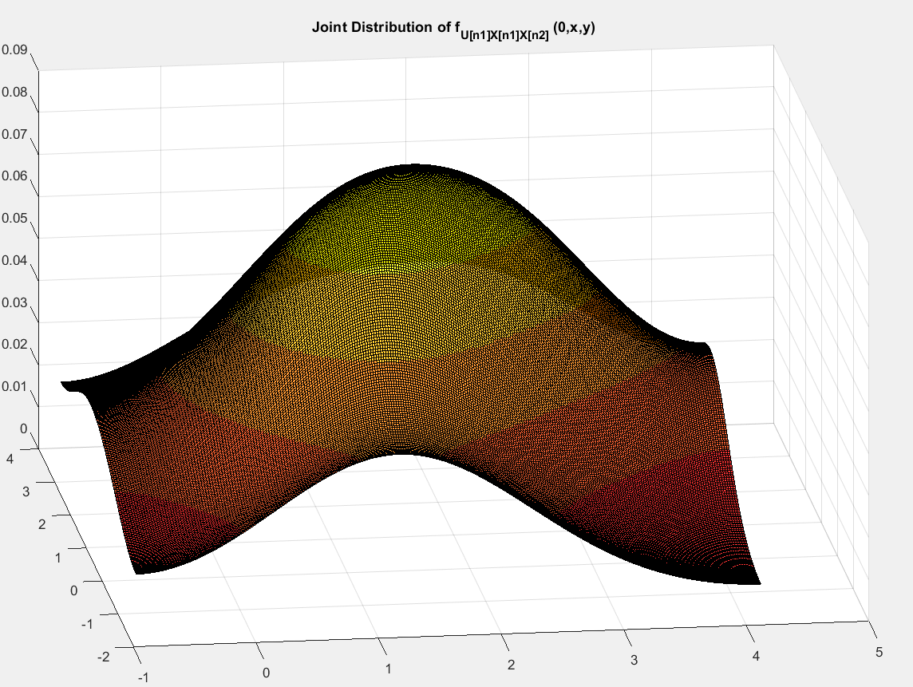

Joint probability density function of f_{U[n1]X[n1]X[n2]} (1,x,y) is given by the graph below,

